CHAPTER 8: THE TIMER

If the Mouse and Keyboard are the "Senses" of your program (allowing it to feel user input), the Timer is its **Heartbeat**.

1. The Core Concept

A Windows Timer is simply an alarm clock that hits the "Snooze" button forever. You tell Windows: *"Poke me every 1000 milliseconds."* Windows replies: *"Okay."* Then, every second, Windows drops a **WM_TIMER** message into your queue.

It doesn't pause your code. It doesn't freeze the system. It just sends a message, exactly like a mouse click, but triggered by time instead of a hand.

2. Why do we need this? (The Translation)

Here is what they actually mean in practice:

A. "Multitasking" (The Chopping Block Technique)

**The Problem:** You need to process a 500-page document. If you do it in one loop, the window freezes, turns white, and says "Not Responding" for 10 seconds.

**The Timer Solution:**

* Set a timer for 10ms.
* When WM_TIMER arrives, process **Page 1**. Return.
* Windows updates the screen.
* WM_TIMER arrives. Process **Page 2**. Return.

**Result:** The app stays responsive while doing heavy work in the background.

B. "Pacing Movement" (Game Loop)

**The Problem:** Computers have different speeds. A loop like x++ might run at 500mph on a new PC and 5mph on an old one.

**The Timer Solution:** You move the character only when the Timer fires (e.g., every 30ms).

**Result:** Your Space Invaders move at the same speed on *every* computer. This is the foundation of the **Game Loop**.

C. "Real-Time Updates" (The Dashboard)

**Usage:** A clock on the wall, a CPU usage meter, or a download progress bar.

**Mechanism:** You don't need to check the time constantly in a frantic loop. You just wait for the heartbeat to say "Update the display now."

D. "Autosave" (The Safety Net)

**Usage:** Word processors.

**Mechanism:** Every 5 minutes (300,000 ms), the timer fires. You save the file to a temp folder. If the power goes out, the user only loses 5 minutes of work.

3. A Critical Warning

The Windows Timer is **not precise**. If you ask for a timer every **10ms**, but your program is busy loading a massive image that takes 50ms, **you will miss 4 timer ticks.** They do not "stack up." You will just get the next one when the system is free.

**Next Step:** Now that we know *what* it is, we need to learn *how* to turn it on. The next section of your notes likely covers the SetTimer function and the two ways to handle it (Case Statement vs. Callback). Shall we look at that?

If the concept is the "Heartbeat," then SetTimer is how you start the heart, and KillTimer is how you stop it.

4. Starting the Clock: SetTimer()

You don't "create" a timer object like a variable. You ask Windows to allocate one for you.



The Arguments:

* **hWnd (The Target):** The handle of the window that will receive the messages. "When the alarm goes off, ring *this* house."
* **uID (The Name Tag):** An integer you pick (e.g., 1, 2, or 45). This is crucial if you have multiple timers. You might have ID 1 for a clock and ID 2 for an autosave.
* **uElapse (The Interval):** How often to fire, in **milliseconds**.
  + 1000 ms = 1 second.
  + 60000 ms = 1 minute.
* **lpTimerFunc (The 4th Argument):** *Note:* Your notes imply this is NULL or unused for now. This is for "Method 2" (Callback functions), but in "Method 1," we set this to NULL to force Windows to send WM_TIMER messages instead.

The Notification: WM_TIMER

Once the timer is set, Windows effectively sets a stopwatch. When it hits 0, it drops a message in your queue.

Inside our Window Procedure:



* **wParam**: This holds the **uID** you defined in SetTimer. This is how you differentiate between the "Clock Tick" and the "Autosave."
* **lParam**: In this method, it is 0 (NULL).

Stopping the Clock: KillTimer()

Timers use system resources. If your window closes (WM_DESTROY) and you don't kill the timer, it might keep running in the background, wasting CPU.

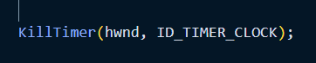

**The Arguments:**

* **hWnd**: The window that owns the timer.
* **uID**: The specific ID of the timer you want to stop. (If you have two timers running, this lets you stop the Clock but keep the Autosave running).

**Summary of the Lifecycle**

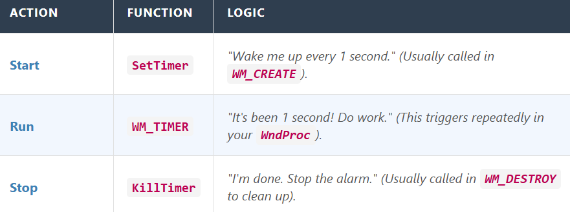

Timer Resolution, Performance, and Message queuing

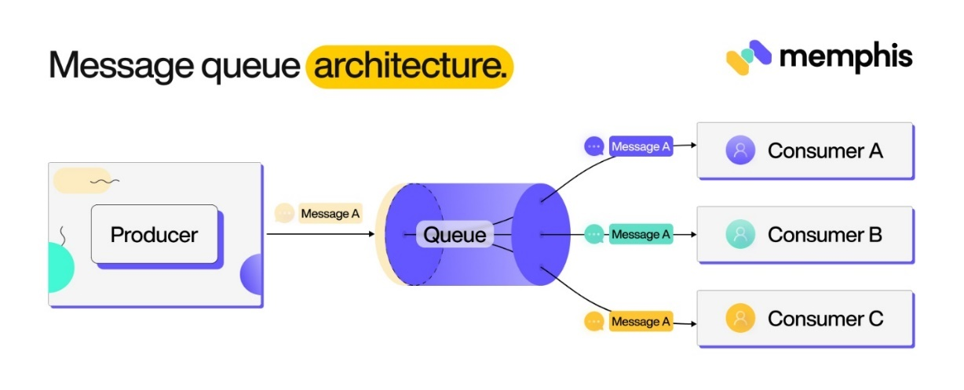

This section details why the Windows Timer is "good enough" for a clock, but "terrible" for a scientific experiment requiring microsecond precision.

1. Code Cleanup

Your notes contained a few typos (like GetWindowHand1e and HWt•4D). Here is the corrected syntax:

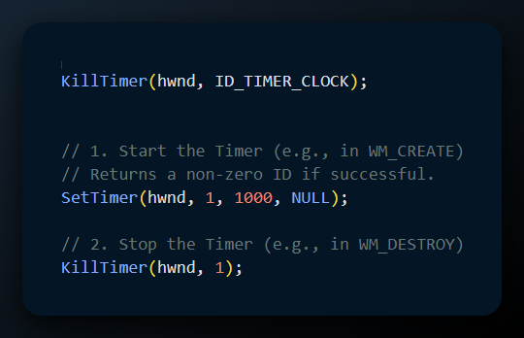

2. The "55 Millisecond" Rule (Resolution)

The notes state that the resolution is typically **55ms**. This is a historical quirk of the IBM PC hardware (which ticked 18.2 times per second).

**What this means:** The timer does not check the time every single millisecond. It checks every "tick" (approx 55ms).

* **Request:** You ask for a timer every **1000ms**.
* **Reality:** Windows rounds this to fit the heartbeat. It might fire at **989ms** or **1044ms** depending on when the system clock ticks.
* **Conclusion:** Never use SetTimer for precise music sequencing or scientific measurements. It is "fuzzy."

3. Performance & Threading

* **CPU Load:** A timer set to **1ms** is dangerous. It forces the system to generate thousands of messages per second, potentially choking the CPU and making the application unresponsive.
* **Single-Threaded:** The standard Windows timer is associated with the **Thread** that created the window.
  + If that thread is busy doing a calculation, the timer cannot fire.
  + If you block the thread (e.g., an infinite loop), the timer stops completely.

4. The Big Concept: Timers are NOT Asynchronous

This is the most misunderstood part of Windows programming.

* **Expectation:** "I set a timer for 5 seconds. In exactly 5 seconds, the OS will interrupt whatever I am doing and run my timer code."
* **Reality:** The timer is **polite**.

When the time is up, Windows does not interrupt you. It simply places a WM_TIMER message at the back of the line (Message Queue).

**The Consequence:** If your application is busy processing a massive WM_PAINT or WM_LBUTTONDOWN event that takes 2 seconds to finish, the WM_TIMER message waits in the queue.

* **Result:** A 1-second timer might actually fire after 3 seconds if the app was busy.
* **Priority:** WM_TIMER is actually a **low-priority** message. Windows will process mouse clicks and keyboard presses *before* handling the timer, to keep the UI feeling responsive.

**This concludes the theory of Timer Behavior.** The next section of the notes usually covers the **Three Methods** of using the timer:

1. **Method 1:** Processing WM_TIMER in the main Window Procedure (the most common way).
2. **Method 2:** Using a Callback Function (for code organization).
3. **Method 3:** CallWindowProc (less common).

Realities of the Windows Timer

This section busts the myth that computers are always perfectly precise. In the Windows API, the standard timer is a "Second Class Citizen" compared to user input.

1. The Queue Problem: FIFO (First-In, First-Out)

Your notes emphasize that the message queue is a **FIFO** structure. Think of it like a line at a grocery store checkout:

* **The Clerk:** Your Processor (CPU).
* **The Customers:** Messages (WM_PAINT, WM_LBUTTONDOWN, WM_CHAR).
* **The Timer:** A customer who joins the **back** of the line.

Even if the timer "rings" at 12:00:00, if the person at the front of the line (e.g., a massive WM_PAINT job) takes 5 seconds to check out, the Timer message sits and waits until 12:00:05.

2. The Implications (The "Drift")

* **No Precision:** If you set a timer for 1000ms, you might get it at 1000ms, 1010ms, or 1500ms. It depends entirely on how busy the application is.
* **The "Merging" Effect:** This is a critical technical detail implied by "handling missing messages."
  + *Scenario:* Your app freezes for 5 seconds. Your 1-second timer should have fired 5 times.
  + *Reality:* Windows realizes the queue is clogged. It throws away the extra timer messages. When you unfreeze, you receive **only one** WM_TIMER message, not five. Windows assumes you only want to know "The time has passed," not "The time passed five times."

3. Strategies for Success

If the standard timer is so unreliable, how do we use it? The notes suggest three strategies:

**a) For UI Updates (The Standard Timer)**

Use SetTimer for things that don't need microsecond accuracy.

* **Good for:** Blinking a cursor, updating a clock on the wall, checking for new emails every 5 minutes.
* **Logic:** "Trigger the update, but check the *actual* time yourself."
  + *Don't say:* Time = Time + 1 (This accumulates errors).
  + *Do say:* Time = GetCurrentSystemTime() (This self-corrects).

**b) For "Heavy Lifting" (Timer Threads)**

If you need to do work at a specific time regardless of the UI being busy, use a **Thread**. A separate thread runs parallel to your window. It doesn't wait in the grocery line; it has its own checkout counter.

**c) For High Precision (Multimedia Timers / System APIs)**

The notes mention the **Multimedia Timer API**. This is specialized hardware-backed timing used for things like:

* Playing music (where a 10ms delay sounds like a glitch).
* Video synchronization.
* *Note:* These consume more battery and CPU power, so use them only when necessary.

**d) Summary**

* **WM_TIMER** is polite. It waits its turn.
* **WM_TIMER** messages do not stack; they merge if the app is slow.
* **Strategy:** Use it to "wake up" your app, but always check the system clock to see what time it *actually* is.

USING THE TIMER: FOUR METHODS

There are three main methods for using the timer in Windows programming:

METHOD 1: SIMPLE TIMER

This is the standard way 90% of Windows programs use timers. It relies on the message loop to deliver "wake up" calls to your main window procedure.

1. How it Works

You ask Windows to send a message to your main window every X milliseconds. You catch this message just like a mouse click or a key press.

2. Setting the Timer

You typically start the timer when the window is created (WM_CREATE).

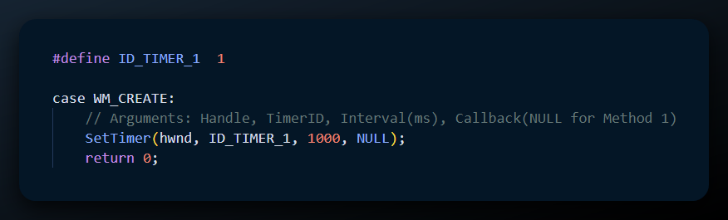

* **hwnd**: "Send the alarm to *this* window."
* **uID**: "Name this alarm '1'." (This is crucial if you have more than one timer).
* **uElapse**: "Ring every 1000ms (1 second)."
* **NULL**: This tells Windows, "Don't call a special function; just send me a WM_TIMER message."

3. Handling the Message (WM_TIMER)

When the time is up, your WndProc receives WM_TIMER.

**The Critical Logic:** If you only have one timer, you can ignore wParam. But if you have multiple timers (e.g., one for a clock, one for an autosave), you **must** check wParam.

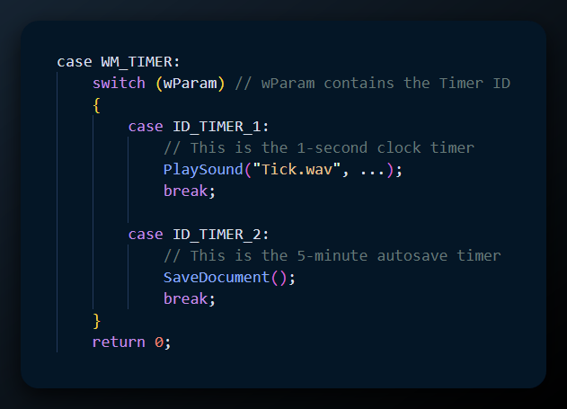

4. Stopping the Timer

To stop the noise/processing, you call KillTimer, usually when the window is destroyed.

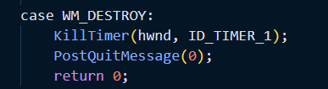

**Note:** If you forget to kill the timer, it *usually* dies with the window, but it is bad practice to rely on that. Explicitly killing it frees system resources immediately.

**Key Takeaway for Method 1:**

* **Pros:** Easiest to implement. Runs in the same thread as your UI (so you can safely draw to the screen).
* **Cons:** Not precise. Can be delayed if your app is busy.

Example: Handling Two Timers

**Handling Multiple Timers** and the analysis of the **BEEPER1** program.

This section moves from theory to practice. It shows how to juggle multiple time-based tasks and how to build a simple application that "pulses" (beeps and flashes) using the timer.

1. Handling Multiple Timers (The Switch Technique)

If your application needs to do two different things at different speeds—like updating a clock every second (1000ms) but checking for new emails every minute (60000ms)—you use the **Timer ID**.

**Setup:** You call SetTimer twice with different IDs.

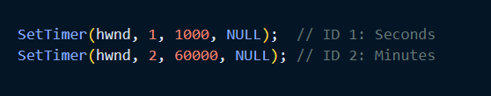

**The Handler:** Inside WM_TIMER, you simply check wParam.

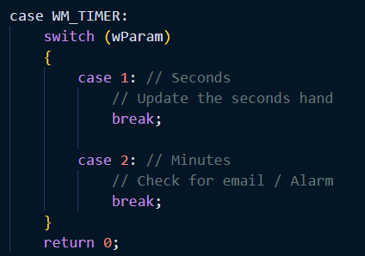

2. Modifying a Running Timer

A useful trick mentioned in the notes is **Resetting** a timer.

* **Scenario:** You have a clock showing seconds (Tick... Tick...). The user minimizes the app. You don't want to waste CPU drawing seconds anymore.
* **Action:** You call SetTimer(hwnd, 1, 60000, NULL).
* **Result:** You **do not** need to KillTimer first. Calling SetTimer with an existing ID simply **overwrites** the old instruction. The timer now slows down to once per minute immediately.

3. Case Study: The BEEPER1 Program

BEEPER1 is the "Hello World" of timers. It creates an annoying program that beeps and flashes red/blue every second.

BEEPER1 is essentially the “Hello World” example for using timers in Windows programming. It’s a deliberately annoying little program that beeps and flashes between red and blue once every second.

When the program starts and receives the WM_CREATE message, it sets up a timer by calling SetTimer(hwnd, 1, 1000, NULL). This tells Windows to send a timer message to the window every 1,000 milliseconds, or once per second.

Each time the timer fires, the window receives a WM_TIMER message. This acts as the program’s heartbeat. First, the program plays the default Windows system sound using MessageBeep(0). Next, it flips a boolean variable called fFlipFlop, switching it from TRUE to FALSE or from FALSE back to TRUE.

Finally—and most importantly—it calls InvalidateRect(hwnd, NULL, FALSE). This marks the entire window as needing to be redrawn and forces Windows to send a WM_PAINT message right away.

When WM_PAINT is handled, the program decides what color to display based on the value of fFlipFlop. If the flag is TRUE, it creates a solid red brush using CreateSolidBrush(RGB(255, 0, 0)).

If the flag is FALSE, it creates a solid blue brush with CreateSolidBrush(RGB(0, 0, 255)). The program then fills the window with that color using FillRect, causing the screen to flash red and blue alternately.

Finally, when the program is closing and receives the WM_DESTROY message, it calls KillTimer to clean up the timer and release system resources.

4. Key Technical Takeaways

* **State Management:** The timer itself doesn't draw. The timer just changes a **variable** (fFlipFlop) and requests a redraw. This separates "Logic" from "Drawing."
* **GetClientRect:** You use this in WM_PAINT to ensure you color the *whole* window, even if the user resized it 5 seconds ago.
* **Efficiency:** By using KillTimer, you ensure the system stops tracking your window once it closes.



METHOD 2: USING A DIALOG BOX PROCEDURE

This method is functionally almost identical to Method 1, but it is applied to **Dialog Boxes** (pop-up windows like "Settings" or "About") rather than the main application window.

1. The Context

In Windows programming, a **window** and a **dialog box** are similar but not identical.

* A **window** processes messages through a WndProc.
* A **dialog box** processes messages through a DlgProc.

Method 2 demonstrates that SetTimer works just as well inside a dialog box as it does in a standard window. Once the timer is set, the dialog box procedure can handle the WM_TIMER message and perform whatever actions are needed.



2. The Differences

While the logic is the same, the location of the code changes slightly:

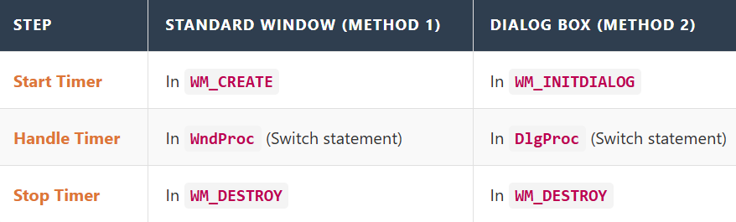

3. Why use this?

The notes mention: *"Useful if you want to use the timer to perform actions that affect multiple dialog boxes."*

**Example:** Imagine you have a "Download Progress" dialog box.

* You don't want the *Main Window* to handle the download logic.
* You want the *Dialog Box itself* to own the timer.
* When the timer ticks, the Dialog Box updates its own progress bar directly. This keeps your code modular—the Main Window doesn't need to know the details of the download.

METHOD 3: USING A DEDICATED TIMER THREAD

This is the "heavy lifting" approach. While the previous methods (like SetTimer) rely on the main window’s message loop, this method creates a completely separate path of execution.

**The Main Idea:** Think of your main program as the **Manager**. Instead of the Manager stopping their work every few seconds to check a clock, they hire an **Assistant**   
(the Worker Thread).

The Assistant’s *only* job is to watch the clock and tap the Manager on the shoulder (send a notification) when time is up.

**Why use this?**

* **Precision:** It doesn't get blocked if your main window is busy moving or resizing.
* **Non-blocking:** Heavy calculations in the timer won't freeze your UI.

The Code Structure

Here is the standard syntax for spinning up that new thread using CreateThread:

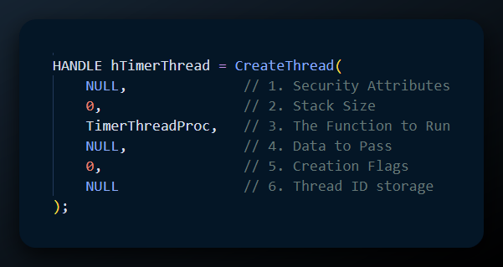

Breaking Down the Parameters

Here is what those arguments actually mean in plain English:

1. **Security Attributes (NULL):**
   * **What it is:** Rules about who can control this thread and if child processes inherit it.
   * **Plain English:** Passing NULL just means "Use the default settings." We aren't doing anything fancy with permissions.
2. **Stack Size (0):**
   * **What it is:** The amount of memory reserved for this thread's variables and history.
   * **Plain English:** Passing 0 tells Windows to use the default size (usually 1 MB). This is almost always enough unless your thread is doing massive recursion.
3. **Thread Function (TimerThreadProc):**
   * **What it is:** The actual name of the function you want this thread to execute.
   * **Plain English:** This is the "Job Description." As soon as the thread starts, it jumps to this function and runs code there.
4. **Thread Parameters (NULL):**
   * **What it is:** A pointer to a variable or structure if you need to pass data into the thread.
   * **Plain English:** In this example, we pass NULL because the thread doesn't need any starter data. If it did, we would pass a pointer here.
5. **Creation Flags (0):**
   * **What it is:** Instructions on how to start.
   * **Plain English:** Passing 0 means "Start running immediately." Alternatively, you could tell it to start "Suspended" (paused) if you wanted to wake it up later.
6. **Thread ID (NULL):**
   * **What it is:** A place to store the unique ID number Windows assigns to the thread.
   * **Plain English:** We passed NULL because we don't care about the ID number right now; we only care about the *Handle* (hTimerThread) returned by the function.

Important "Gotchas" (Notes for the Developer)

* **The Handle:** The function returns a HANDLE. You need to save this! You will need it later to close the thread cleanly or check if it is still running.
* **Concurrency:** Since two things are now running at once (your main window and this timer), be careful accessing the same variables. They might try to write to the same memory at the same time and crash the app.

Quick Review

**Question 1:** If you set the Stack Size parameter to 0, does that mean the thread has no memory? *(Answer: No. It means it uses the system default size, which is typically 1MB.)*

**Question 2:** Why might you choose this complex method over a simple SetTimer? *(Answer: SetTimer relies on the message loop. If your application is busy processing a large file, SetTimer messages might get delayed. A Thread Timer runs independently.)*

**Question 3:** What happens if you pass NULL for the Security Attributes? *(Answer: The thread gets default security settings and the handle cannot be inherited by child processes.)*

Completing Method 3: The Worker Function (TimerThreadProc)

We created the thread in the previous step, but now we need to define **what the thread actually does**. This is the TimerThreadProc.

**The Logic:** This function acts like an infinite loop running in the background. It sits there, waits for a signal (or a specific amount of time), and then sends a message to the main window saying, "Hey, time is up!"



Key Takeaways:

* **WaitForSingleObject**: This is the "pause" button. It stops this thread from eating up 100% of your CPU. It waits efficiently until the kernel object (hTimerEvent) says it's time.
* **PostMessage**: This is how the background thread talks to the UI thread. It drops a note in the mailbox (WM_TIMER) and immediately goes back to waiting.

Method 2: Using a Call-Back Function

Now, let's look at a "middle-ground" approach.

**The Main Idea:** In the standard method (Method 1), the timer sends messages to your main Window Procedure (WndProc). This can make your WndProc huge and messy. In **Method 2**, we tell Windows: "Don't bother the main WndProc. When this timer goes off, call **this specific function** instead."

Think of it like diverting a specific type of phone call directly to a specialist, so the receptionist doesn't have to deal with it.

1. The Call-Back Function (TimerProc)

You need to write a specific function that matches the signature Windows expects. This function will *only* handle timer alerts.

**The Parameters Explained:**

* **hwnd**: The ID of the window asking for the timer.
* **message**: This will always be WM_TIMER. (Windows is just being consistent with other message formats).
* **iTimerID**: The ID number of the timer. Useful if you have multiple timers going to the same function (e.g., one for a clock, one for a blinking cursor).
* **dwTime**: The "System Uptime." It tells you how many milliseconds have passed since Windows booted up.

**The Code Structure:**



2. Setting the Timer

To make this happen, we use SetTimer again, but with a twist in the 4th argument.

**The Code:**



**What changed?** Previously, we passed NULL as the last argument, which defaulted the messages to WndProc. Now, by passing TimerProc, Windows knows to route the traffic directly to that function.

Important "Gotchas"

* **Static/Global:** The TimerProc function usually needs to be a global function or a static member of a class. It cannot be a regular member function of a C++ class because the "hidden this pointer" confuses Windows.
* **Blocking:** Even though this is a separate function, **it still runs on the main UI thread**. If you do a heavy calculation inside TimerProc, your window will freeze until it finishes.

Quick Review

**Question 1:** In the Thread method (Method 3), why do we use PostMessage instead of just updating the window text directly? *(Answer: You generally cannot touch UI elements (like text boxes) from a background thread. You must ask the main thread to do it for you via a message.)*

**Question 2:** In Method 2, what happens if you put an infinite loop inside your TimerProc? *(Answer: The application hangs/freezes. The callback runs on the main thread, so it blocks the UI.)*

**Question 3:** What is the 4th argument of SetTimer used for? *(Answer: It specifies the Callback function. If it is NULL, the timer message goes to the main Window Procedure.)*

Real-World Examples: BEEPER1 vs. BEEPER2

In Charles Petzold’s book, he uses two programs to demonstrate the difference between the "Standard Method" and the "Callback Method." Both programs do the exact same thing—they beep and flash colors—but they are wired completely differently under the hood.

1. BEEPER1 (Method 1: The Standard Way)

**The Setup:** You call SetTimer inside WM_CREATE and pass NULL as the last argument.

**The Flow:**

1. The timer goes off.
2. Windows posts a WM_TIMER message to your main message queue.
3. Your main **Window Procedure (WndProc)** picks it up.
4. You have to write a case WM_TIMER: inside your main switch statement to handle it.

**The Vibe:** This is like having a CEO (the WndProc) who insists on answering every single phone call personally. It works, but the CEO's office gets very crowded.

2. BEEPER2 (Method 2: The Call-Back Way)

**The Setup:** You call SetTimer inside WM_CREATE, but this time you pass the address of a function called TimerProc.

**The Flow:**

1. The timer goes off.
2. Windows looks at the timer setup and sees you hired a specialist (TimerProc).
3. Windows calls TimerProc directly.
4. **Crucial:** The main WndProc never sees this message. It completely bypasses the main switch statement.

**The Vibe:** This is like the CEO hiring a dedicated assistant for specific tasks. "If the alarm rings, don't tell me; tell the security guard directly."

3. The Comparison: Why choose one over the other?

The output is identical, so why does BEEPER2 matter? It comes down to **Code Hygiene**.

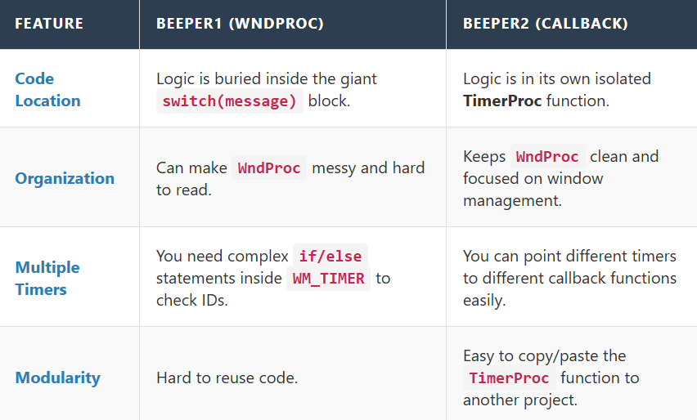

**The Verdict:**

* Use **Method 1 (BEEPER1)** for simple, quick hacks (e.g., a single clock updating every second).
* Use **Method 2 (BEEPER2)** for professional applications, complex timing, or when you want to keep your code organized.

Quick Review

**Question 1:** In BEEPER2, if you look inside the WndProc function, will you find a case WM_TIMER: statement? *(Answer: No. Since the callback handles it, the main window procedure doesn't need to know about it.)*

**Question 2:** If you had three different timers doing three very different things (e.g., a clock, a network check, and an autosave), which method is cleaner? *(Answer: Method 2 (Callback). You can write three separate functions for them instead of cramming all the logic into one WM_TIMER case.)*

**Question 3:** Does using BEEPER2 (Callback) make the program run faster than BEEPER1? *(Answer: Not really. The performance difference is negligible. The benefit is purely for the programmer's organization.)*

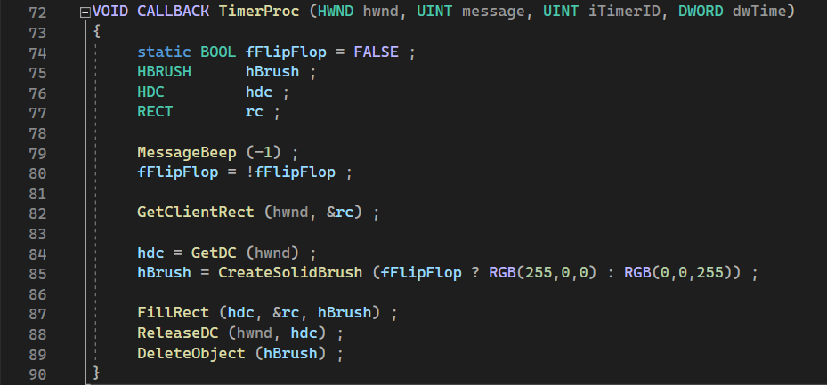

Method 3: The Windowless Timer (Dynamic IDs)

**The Main Idea:** In the previous methods, *you* decided the Timer ID (e.g., #define ID_TIMER 1). You told Windows, "Create a timer and call it Number 1." In **Method 3**, you say, "I don't care what you call it, just give me a timer and tell me its ID."

**Why is this different?** This timer is **not attached to any specific window**. This is great for "utility" code—like a background class or a library—that needs a timer but doesn't own a window.

1. Setting the Timer

You use SetTimer again, but you pass NULL for the window handle and 0 for the ID.

**The Code:**



Breaking it down:

* **hwnd (NULL):** "This timer belongs to no window."
* **iTimerID (0):** "I'm not assigning an ID."
* **TimerProc:** You **must** provide a callback function here (as learned in Method 2). Since there is no window, there is no WndProc to catch the message!
* **The Return Value:** This is critical! SetTimer returns a new, unique ID. You **must save this variable**, or you will never be able to stop the timer.

2. Killing the Timer

Since you didn't define the ID yourself, you have to use the variable you saved earlier.



3. Summary: The 4 Ways to Time Things in Windows

You have now covered the four main strategies. Here is a "Cheat Sheet" to help you remember which one to use.

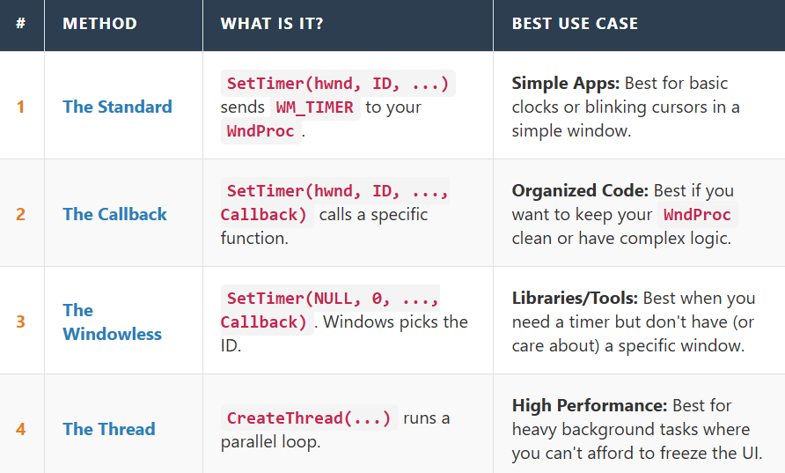

4. Quick Review

**Question 1:** In Method 3, if you lose the iTimerID variable (e.g., you overwrite it), can you stop the timer? *(Answer: No. Since Windows generated a random ID for you, if you lose that number, the timer will run forever until the app closes.)*

**Question 2:** Can you use Method 3 (Windowless) *without* a Callback function? *(Answer: Technically yes, but it's very messy. You would have to manually pull messages from the message loop. It is almost always used with a Callback.)*

**Question 3:** Which method is "Method 2: Using a Dialog Box Procedure" from your summary list? *(Answer: That is actually just Method 1! A Dialog Box Procedure is basically the same thing as a Window Procedure, just for dialogs. It still relies on receiving WM_TIMER messages.)*

*Program code Chapter 8 DigClock…*

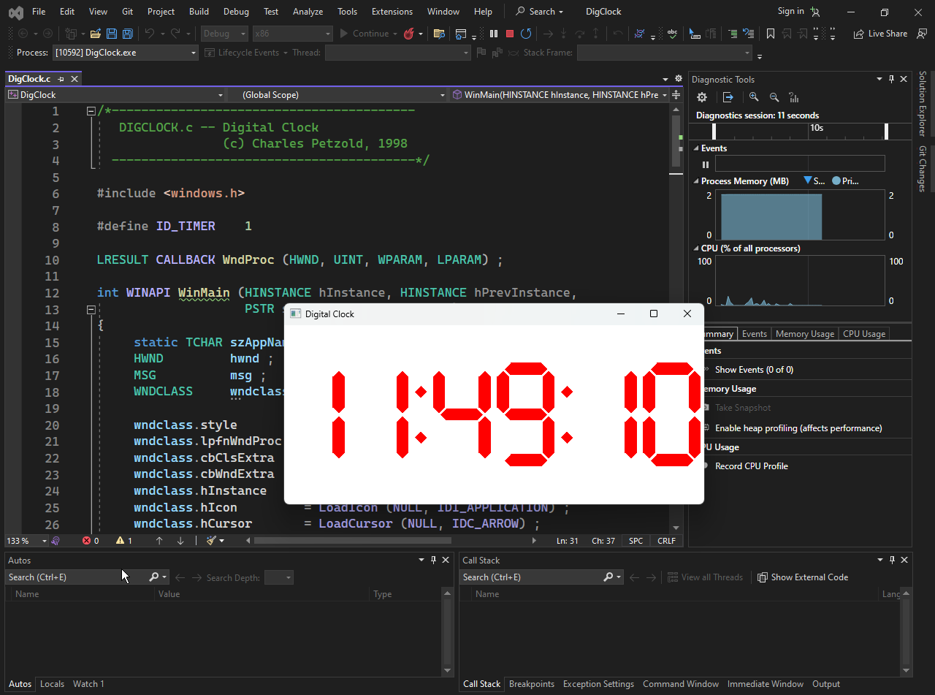

The DIGCLOCK Window Procedure (WndProc)

The WndProc is the brain of this digital clock. It reacts to six specific life events to ensure the clock looks right and ticks on time.

1. Waking Up (WM_CREATE)

When the window first loads, we need to prep our tools.

* **The Tools:** We create a **Red Brush** (for the digits) and store it.
* **The Pulse:** We start a **1-second Timer**.
* **The Cleanup:** *Crucial Point:* Since we created a GDI Object (the Brush), we *must* delete it later.

2. Adapting to the System (WM_SETTINGCHANGE)

If the user goes into Windows Settings and changes their time format (e.g., from 12-hour to 24-hour), our clock needs to know.

* **The Action:** We call GetLocaleInfo.
* **The Logic:** We check two flags:
  1. **24-Hour Format?** (True/False)
  2. **Suppress Leading Zeros?** (e.g., showing "9:00" instead of "09:00").
* **The Refresh:** We force a redraw so the style updates immediately.

3. Handling Resizes (WM_SIZE)

When the user drags the window corners, the clock needs to stay centered.

* **The Action:** We simply save the new width and height (cxClient, cyClient) into static variables so the painting logic knows the new boundaries.

4. The Heartbeat (WM_TIMER)

Every 1000ms (1 second), the timer fires.

* **The Action:** InvalidateRect(hwnd, NULL, TRUE);
* **Translation:** "Hey Windows, my entire screen is 'dirty' (out of date). Please schedule a repaint ASAP."
* **Note:** This triggers a WM_PAINT message automatically.

5. Drawing the Clock (WM_PAINT)

This is where the heavy lifting happens. We don't just draw text; we draw *shapes* to make digital-style numbers.

**The Coordinate System Trick (MM_ISOTROPIC):** Instead of worrying about pixels (which change if the window gets smaller), we set up a **Virtual Coordinate System**.

**The Goal:** We want the clock to look correct regardless of the window size (responsive design).

**The Logic:**

* **Mapping Mode:** Set to MM_ISOTROPIC. This means "keep the aspect ratio perfect." Circles stay circles; they don't become ovals when you stretch the window.
* **The Virtual Canvas:** We define the clock size as **276 x 72 units**.
* **Centering:** We map the center of that virtual canvas to the center of the actual window (SetViewportOrgEx).

**The Drawing:**

* We select our **Red Brush** (fill color).
* We select a **NULL Pen** (no outlines).
* We call a helper function DisplayTime to draw the actual polygons for the numbers.

6. Shutting Down (WM_DESTROY)

Clean up your mess before you leave!

* **Stop the Timer:** KillTimer.
* **Delete the Brush:** DeleteObject. (If you forget this, you leak memory).
* **Quit:** PostQuitMessage.

7. Important "Gotchas" & Analysis

**I) The Inefficiency of InvalidateRect**

* **The Problem:** Every second, we tell Windows to erase and redraw the *entire* window background (TRUE parameter).
* **The Result:** If you look closely, the window might flicker slightly.
* **The Fix (Advanced):** Ideally, we should only invalidate the rectangle where the numbers actually changed (e.g., only the seconds digit), but for a simple example, repainting the whole thing is acceptable.

**II) Why the NULL Pen?**

* We want the digits to look like solid blocks of red light. If we used a standard pen, they would have black outlines, which ruins the "digital LED" look.

8. Quick Review

**Question 1:** Why do we create the Red Brush in WM_CREATE instead of WM_PAINT? *(Answer: Efficiency. If we created it in WM_PAINT, we would be creating and destroying a brush object every single second. Creating it once at the start is much faster.)*

**Question 2:** What does MM_ISOTROPIC ensure? *(Answer: It ensures the aspect ratio stays the same. If you resize the window to be very tall and skinny, the clock won't stretch to look tall and skinny; it will keep its proportions.)*

**Question 3:** Does WM_TIMER draw the numbers? *(Answer: No! WM_TIMER simply invalidates the rectangle. This tells Windows to generate a WM_PAINT message, which actually does the drawing.)*

RETRIEVING TIME: GETLOCALTIME & SYSTEMTIME

To display the time, we first need to ask Windows what time it is. The DisplayTime function starts by calling GetLocalTime.

1. The Data Structure: SYSTEMTIME

Windows returns the time in a specific C-style structure called SYSTEMTIME. It breaks time down into easy-to-read integer parts (Year, Month, Day, etc.).

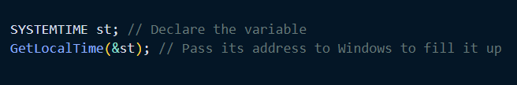

**The Structure Definition:** All fields are type WORD (which is just a 16-bit unsigned integer, essentially a short).

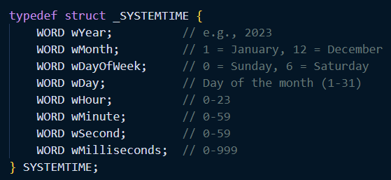

2. The "Gotchas" (Indexing)

Programmers often get tripped up here because Windows is inconsistent with   
0-based vs. 1-based counting.

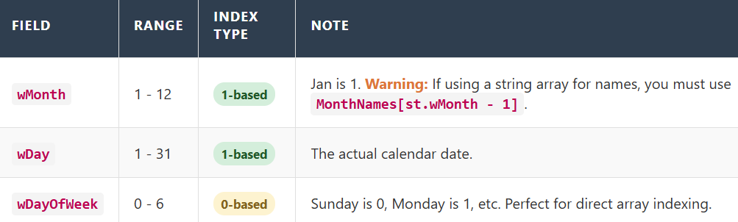

3. Local Time vs. System Time (UTC)

Windows gives you two ways to ask for the time. It is crucial to know the difference.

GetLocalTime (What we use for Clocks)

* **What it returns:** The time adjusted for your specific **Time Zone** and **Daylight Savings**.
* **Analogy:** The "Wall Clock" time. If you are in New York, it says 5:00 PM.
* **Usage:** UI elements, clocks, user logs.

GetSystemTime (What we use for Internals)

* **What it returns:** **UTC** (Coordinated Universal Time), roughly equivalent to GMT (Greenwich Mean Time).
* **Analogy:** The "Universal" time. If you are in New York, it says 10:00 PM (ignoring your offset).
* **Usage:** File timestamps, server synchronization, cryptography.

**Why does this matter?** If you write a chat app and use GetLocalTime for message timestamps, a user in London might see a message from a user in New York arrive "5 hours in the future." Always use GetSystemTime (UTC) for logic/storage, and GetLocalTime only for display.

4. Setting the Time

Just as you can *Get* the time, you can *Set* it (if you have Administrator privileges).

* SetLocalTime(&st)
* SetSystemTime(&st)

*Note: Changing the system time affects the entire computer, not just your program. Use with caution!*

5. Quick Review

**Question 1:** If wDayOfWeek is 0, what day is it?   
*(Answer: Sunday.)*

**Question 2:** If you want to log precisely when an error occurred so a developer in another country can debug it, which function should you use?   
*(Answer: GetSystemTime (UTC). This avoids confusion about time zones.)*

**Question 3:** Is wMonth 0-based (0 = Jan) or 1-based (1 = Jan)?   
*(Answer: 1-based. January is 1.)*

DRAWING SEVEN-SEGMENT DIGITS WITHOUT A SPECIALIZED FONT

Most programs just use a font (like Arial or Courier) to write text. DIGCLOCK is cooler: it manually draws the "Seven-Segment Display" shapes (like an old VCR or alarm clock).

1. The Logic: Segments

A 7-segment digit is just 7 individual lights. To make the number "8," you turn them all on. To make "1," you only turn on the two right-side segments.

The program uses a **Boolean Map** (an array of 0s and 1s) to know which lights to turn on for each number.



2. The Geometry: Polygons

Each "segment" isn't just a line; it's a hexagon (a 6-sided shape with pointed ends). The program defines the exact X,Y coordinates for these 6 points in a POINT structure array.

The Drawing Loop

The function DisplayDigit is the artist. It looks at the number you want (e.g., "5"):

1. It checks the Boolean Map: "Which segments does '5' need?"
2. It loops through all 7 segments.
3. If a segment is needed (1), it calls Polygon() to fill that shape red.
4. If not (0), it skips it.

The Trick: Moving the "Camera" (Window Origin)

You might think the code has complicated math to calculate where the *second* digit goes, and then the *third*, etc. Actually, it uses a lazy (and brilliant) trick: **Moving the Origin.**

**Draw Digit 1:** The function thinks it is drawing at (0,0).

**Shift Origin:** The program calls OffsetWindowOrgEx(hdc, 42, 0). *Translation:*   
*"Hey Windows, shift the logical 'coordinate 0' 42 units to the right."*

**Draw Digit 2:** The function *still* thinks it is drawing at (0,0), but it magically appears next to the first one.

The math:

* **Digit Width:** 42 units.
* **Colon Width:** 12 units.
* **Total Width:** (6 digits × 42) + (2 colons × 12) = **276 units**.

Internationalization: Being a Good Global Citizen

Your computer knows where you live. If you are in the US, you might prefer "2:00 PM". If you are in Germany, you might prefer "14:00". DIGCLOCK respects this.

1. Reading the Settings (GetLocaleInfo)

Instead of guessing, the program asks Windows what the user prefers. It does this using GetLocaleInfo with specific "Question IDs":

**LOCALE_ITIME**: "Do you use a 12-hour clock or 24-hour clock?"

Returns '0' for 12-hour, '1' for 24-hour.

**LOCALE_ITLZERO**: "Do you want a leading zero on the hour?"

Returns '0' for "9:00", '1' for "09:00".

2. When to Ask?

**At Startup (WM_CREATE):** To set the initial look.

**When Settings Change (WM_SETTINGCHANGE):** This is crucial. If the user changes their Region settings while your app is running, Windows broadcasts this message. DIGCLOCK catches it and re-reads the settings immediately.

3. Limitations of this Example

DIGCLOCK is a bit hard-coded.

It *only* draws colons (:). If a user in a specific country prefers a dot (.) or a dash (-) as a separator, DIGCLOCK ignores them because it only knows how to draw polygons for colons.

A "Perfect" Windows app would use GetTimeFormat to handle all these weird cultural differences automatically, but that prints text strings, not cool polygon shapes.

4. Quick Review

**Question 1:** Why does the program use OffsetWindowOrgEx after drawing each digit? *(Answer: To avoid complex coordinate math. It allows the drawing function to always draw at (0,0), while Windows handles shifting the position.)*

**Question 2:** How does the program know which segments to light up for the number "3"? *(Answer: It looks up the pattern in a pre-defined boolean array (the "font" logic).)*

**Question 3:** If I change my computer's region to "France" while the clock is running, what happens? *(Answer: Windows sends WM_SETTINGCHANGE. The app catches it, calls GetLocaleInfo, sees that France uses 24-hour time, and updates the display instantly.)*

*Analogue clock code next program….*

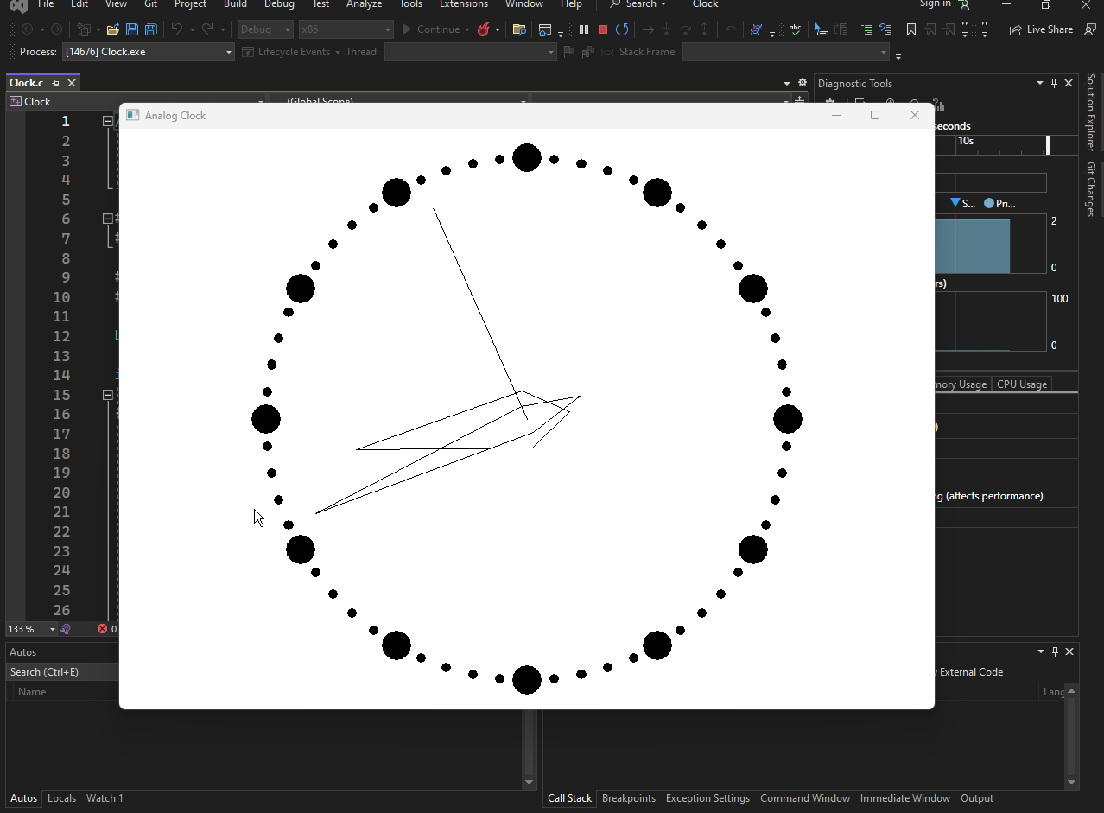

Isotropic Mapping: The Perfect Coordinate System

For an analog clock, you want a circle to look like a circle, not an oval, regardless of how the user resizes the window. To achieve this, we use **Isotropic Mapping** again.

1. The Setup (SetMapMode)

We set the mode to MM_ISOTROPIC. This tells Windows: "I want 1 unit on the x-axis to equal 1 unit on the y-axis. No stretching."

2. The Virtual Grid

We define a virtual grid that is **1000 units** in every direction from the center.

* **Window Extents:** Set to (1000, 1000).
* **Viewport Extents:** Set to half the client width/height.
* **The Result:** The center of your window is now (0,0). The top edge is 1000, the right edge is 1000, etc. This makes the math for drawing the hands *much* easier.

Rotating Points (Trigonometry 101)

The hardest part of an analog clock is figuring out where the hands point. If the second hand is at "10 seconds," where is that on the screen?

**The RotatePoint Function**

This helper function takes a point (like the tip of a hand pointing at 12:00) and rotates it around the center (0,0) by a specific angle.

**The Math:** The code uses standard rotation matrix formulas to calculate the new X and Y coordinates:

* **x' (New X):** x * cos(a) + y * sin(a)
* **y' (New Y):** y * cos(a) - x * sin(a)

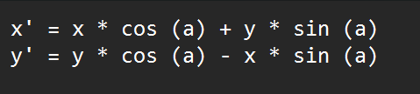

*Note: The formula for y' uses a minus sign because in Windows GDI (and many computer graphics systems), the Y-axis often works differently than in standard high school geometry.*

Drawing the Clock Face

The clock needs 60 dots around the edge (one for each minute/second).

The Strategy:

**Start at 12:00:** We assume a dot exists at (0, 900). (Remember, our grid goes up to 1000, so 900 is near the edge).

**Rotate & Draw:** We loop 60 times.

* For each step, we rotate the coordinates by **6 degrees** (360 degrees / 60 dots = 6).
* **Big Dots:** Every 5th dot (the hour markers) is drawn larger (100 units wide).
* **Small Dots:** The other dots are smaller (33 units wide).

**The Tool:** We use the Ellipse function to draw the actual dots.

Drawing the Hands

The hands are just shapes (triangles/polygons) that we define once pointing **straight up (12:00)**.

The Process:

**Define the Shape:** We have an array of POINT structures that outline the hand (e.g., a wide base, a long pointy tip).

**Calculate the Angle:**

* **Hour Hand:** (Hour * 30) + (Minute / 2) degrees.
* **Minute Hand:** (Minute * 6) degrees.
* **Second Hand:** (Second * 6) degrees.

**Rotate:** We pass the shape and the angle to our RotatePoint function.

**Draw:** We use Polyline to draw the rotated shape on the screen.

**Optimization Note:** The code is smart. It checks a flag (bChange). If only the *seconds* have changed (which happens 60 times a minute), it doesn't waste time recalculating and redrawing the *hour* and *minute* hands unless necessary.

Quick Review

**Question 1:** Why do we set the Window Extents to 1000? *(Answer: It creates a fixed, easy-to-use coordinate system. We know the clock radius is always 1000 units, regardless of the actual pixel size of the window.)*

**Question 2:** If we have a point at (0, 100) and rotate it 90 degrees clockwise, where does it end up? *(Answer: (100, 0). It moves from the 12:00 position to the 3:00 position.)*

**Question 3:** Why does the formula for y' subtract x * sin(a)? *(Answer: It's part of the standard rotation matrix math to account for the rotation direction in the Cartesian plane.)*



CLOCK.C: The Animation Logic

The most interesting part of the clock isn't the math; it's how it animates the hands without flickering like crazy.

1. The Strategy: "Erase and Redraw"

In modern graphics (like DirectX), we just wipe the whole screen and draw the next frame. In old-school GDI, that's too slow. Instead, we use a smart "overwrite" trick.

**The Loop (inside WM_TIMER):**

**Check Time:** Get the new time.

**The "Erase" Step:**

* Select a **WHITE** pen (or the background color).
* Draw the *old* hands exactly where they were a second ago.
* *Result:* The hands disappear (white on white).

**The "Draw" Step:**

* Select a **BLACK** pen.
* Draw the *new* hands at the new angles.
* *Result:* The hands appear in their new position.

2. Optimization

Drawing takes CPU power. We don't want to redraw the Hour Hand 60 times a minute if it hasn't moved.

* **The Check:** The program stores the previous time in dtPrevious.
* **The Logic:** If NewHour == OldHour, we skip the Erase/Draw step for the hour hand. We only update the Second hand every single tick.

New Program: WHATCLR (The "Eyedropper")

This program is a utility tool. It follows your mouse cursor and tells you the RGB color (in Hex code) of the exact pixel you are pointing at—even if you are pointing at *another* application.

*WhatClr program next, code inside the chapter 8 folder…*



1. The Challenge

Normally, a window can only "see" and "draw" inside its own borders. If you try to read pixels outside your window, Windows usually blocks you. **The Solution:** We need a special key to the whole monitor.

2. The Special DC: CreateDC("DISPLAY", ...)

To read pixels from anywhere on the screen, we create a **Device Context (DC)** for the entire display driver, not just a window.

* **CreateDC:** Creates a generic DC. We pass "DISPLAY" as the driver name.
* **Result:** GetPixel(hdcScreen, x, y) can now read the color of *any* coordinate on your monitor.
* **Lifespan:** We create this DC once in WM_CREATE and keep it alive until the app closes.

3. The Window Style (WS_BORDER)

This is a tiny utility app, so we don't want the user stretching it.

* **The Style:** We use WS_BORDER (and typically remove WS_THICKFRAME).
* **The Result:** A window with a thin border that **cannot be resized** by the mouse. It is calculated to be exactly large enough to fit the text.

4. The Loop (WM_TIMER)

The app doesn't wait for you to click. It updates constantly.

1. **Timer Fires (100ms):** Fast enough to feel instant.
2. **Get Cursor:** GetCursorPos(&pt) finds where the mouse is.
3. **Get Pixel:** GetPixel(hdcScreen, pt.x, pt.y) gets the color.
4. **Compare:** If the color changed since the last check, call InvalidateRect to show the new text.

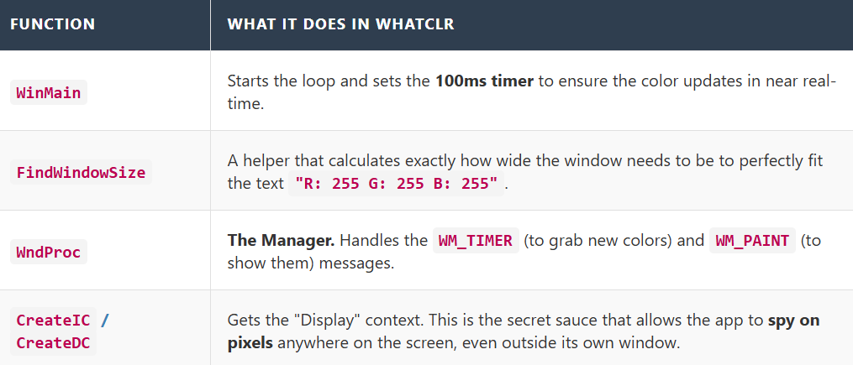

5. Quick Review

**Question 1:** In the Clock program, why do we draw the hands in white first? *(Answer: To "erase" the old hands. Drawing white on a white background makes them invisible, clearing the canvas for the new hands.)*

**Question 2:** In WHATCLR, why can't we just use GetDC(hwnd)? *(Answer: GetDC(hwnd) only gives you access to YOUR window. We need to see the pixels behind other windows or on the desktop wallpaper, so we need a DC for the "DISPLAY".)*

**Question 3:** Does WHATCLR redraw the text every 100 milliseconds? *(Answer: Only if the color actually changed. If you keep the mouse still, it skips the redraw to save CPU.)*

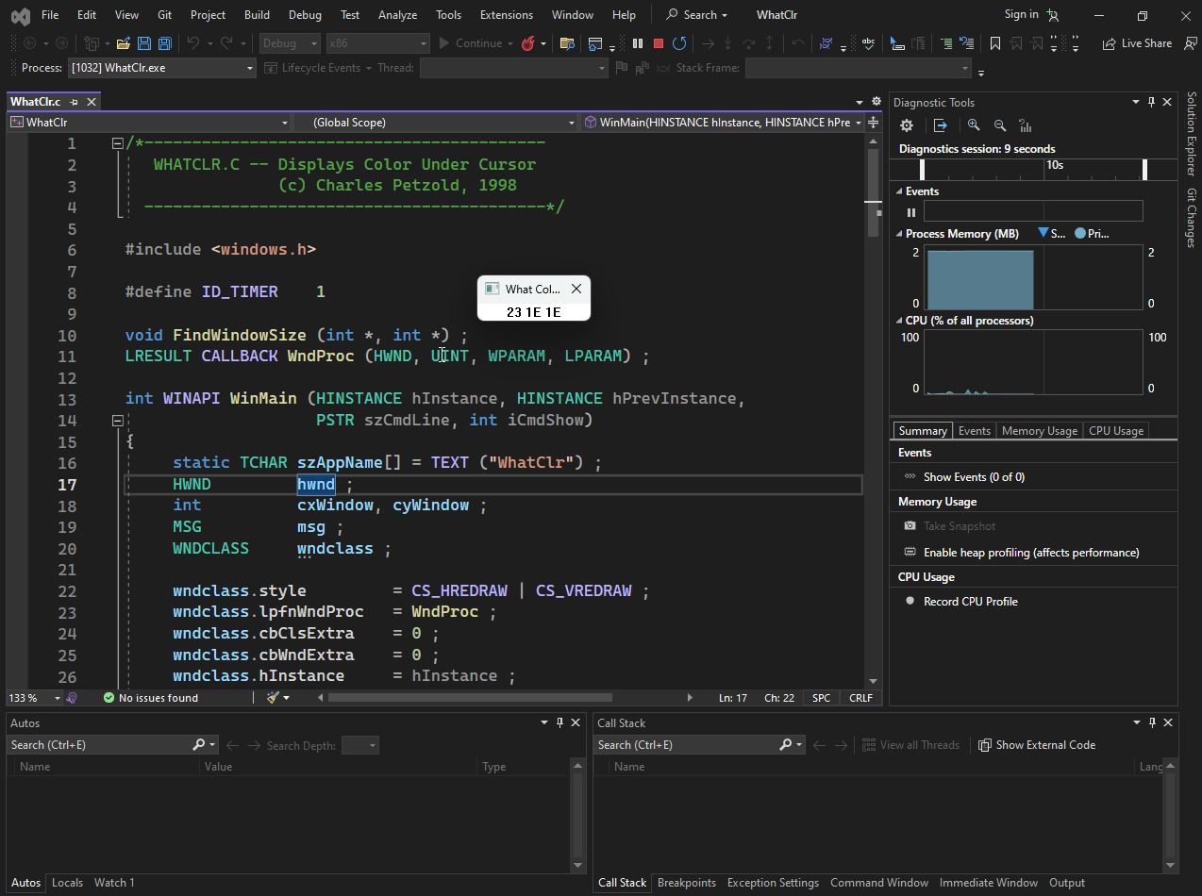

Final Comparison: WHATCLR vs. The Rest

We have built a Beeper, a Digital Clock, an Analog Clock, and now a Color Picker. How does WHATCLR stand out?

1. The "Eyes" (Scope)

* **Previous Apps (DIGCLOCK):** Introverts. They only cared about their own window. They drew inside their own client area and ignored the rest of the screen.
* **WHATCLR:** Extrovert. It looks at the **entire screen**. By using a Device Context for "DISPLAY", it breaks the "sandbox" rule and reads pixels from other applications.

2. The Trigger (Input Source)

* **Previous Apps:** Triggered by **Time** (the clock ticking).
* **WHATCLR:** Triggered by **Time + User Action**. It combines a timer loop with *mouse polling* (GetCursorPos). It connects user behavior (moving the mouse) to the timer's update cycle.

3. The Output (Data)

* **Previous Apps:** Calculated data internally (Math or System Time).
* **WHATCLR:** Scraped data externally. It uses GetPixel to read video memory, which is much slower and "heavier" than just asking for the time, so the timer interval needs to be balanced carefully (not too fast to kill the CPU, not too slow to feel laggy).

50 Questions: Master of Timers & Time

Here is a comprehensive quiz covering everything in Chapter 8.

**Part 1: The Basics (SetTimer & KillTimer)**

1. What is the Windows message identifier for a timer event?
2. What function do you use to start a timer?
3. What is the unit of measurement for the timer interval (e.g., seconds, microseconds)?
4. If you set an interval of 1000, how often does the timer fire?
5. What function do you use to stop a timer?
6. If you forget to call KillTimer, when does the timer stop?
7. Does SetTimer guarantee *exact* precision (e.g., exactly 1000.00ms)?
8. What is the maximum practical resolution (speed) of a standard Windows timer (roughly)?
9. Can you have multiple timers in one application?
10. How does Windows distinguish between two different timers in the same window?

**Part 2: Method 1 (WndProc)**

1. In Method 1, where do you usually call SetTimer?
2. In Method 1, what is the 4th argument of SetTimer set to?
3. Which case in your switch statement handles the timer in Method 1?
4. What variable holds the Timer ID inside the WM_TIMER message?
5. If you have two timers (ID 1 and ID 2) sending messages to WndProc, how do you tell them apart?
6. Does WM_TIMER pause the rest of your application while it runs?
7. Is WM_TIMER a "high priority" or "low priority" message?
8. What happens if your app is busy for 5 seconds but the timer is set to 1 second? Do you get 5 stacked messages or just 1?
9. Can you call drawing functions (like TextOut) directly inside WM_TIMER?
10. Why is it better to call InvalidateRect inside WM_TIMER rather than drawing directly?

**Part 3: Method 2 (Callback Functions)**

1. What is the name of the function signature used for timer callbacks?
2. What do you pass as the 4th argument of SetTimer to use a callback?
3. Does a Timer Callback go through the main WndProc switch statement?
4. What is the hwnd parameter in the Callback function used for?
5. Can a Callback function be a standard C++ class member function? (Yes/No)
6. If you use a Callback, do you still need to assign a Timer ID?
7. Does the Callback function run on a separate background thread?
8. What happens if you put an infinite loop inside your Callback function?
9. What is the dwTime parameter in the Callback function?
10. Is using a Callback faster/more efficient than Method 1, or just better organized?

**Part 4: Methods 3 & 4 (Advanced)**

1. In Method 3 (Windowless), what do you pass as the hwnd parameter?
2. If hwnd is NULL, what timer ID must you pass to SetTimer?
3. How do you know the ID of a Windowless timer?
4. Why must you save the return value of SetTimer in Method 3?
5. What is the main advantage of Method 4 (Threading) over SetTimer?
6. Which API function creates a new thread?
7. In the Thread method, what function acts as the "timer" (the pause button)?
8. How does a worker thread safely update the GUI? (Hint: It posts a...)
9. What is a "Race Condition"?
10. Why is PostMessage safer than SendMessage when communicating from a thread?

**Part 5: The Clocks & Graphics (Applied Knowledge)**

1. What is the difference between GetLocalTime and GetSystemTime?
2. Which struct does GetLocalTime fill with data?
3. Is wMonth in SYSTEMTIME 0-based or 1-based?
4. Is wDayOfWeek in SYSTEMTIME 0-based or 1-based?
5. In the DIGCLOCK program, why did we use MM_ISOTROPIC?
6. What does SetViewportOrgEx do?
7. How did DIGCLOCK draw the numbers without a font? (Which GDI function?)
8. In WHATCLR, which GDI function retrieves the color of a pixel?
9. To get a DC for the whole screen, what string do you pass to CreateDC?
10. Why does WHATCLR check if the color has changed before calling InvalidateRect?